Student Handout - Exercise 1

Exercise Title:
Create a Consultant Registration Form with Complete Validation
Expected Output
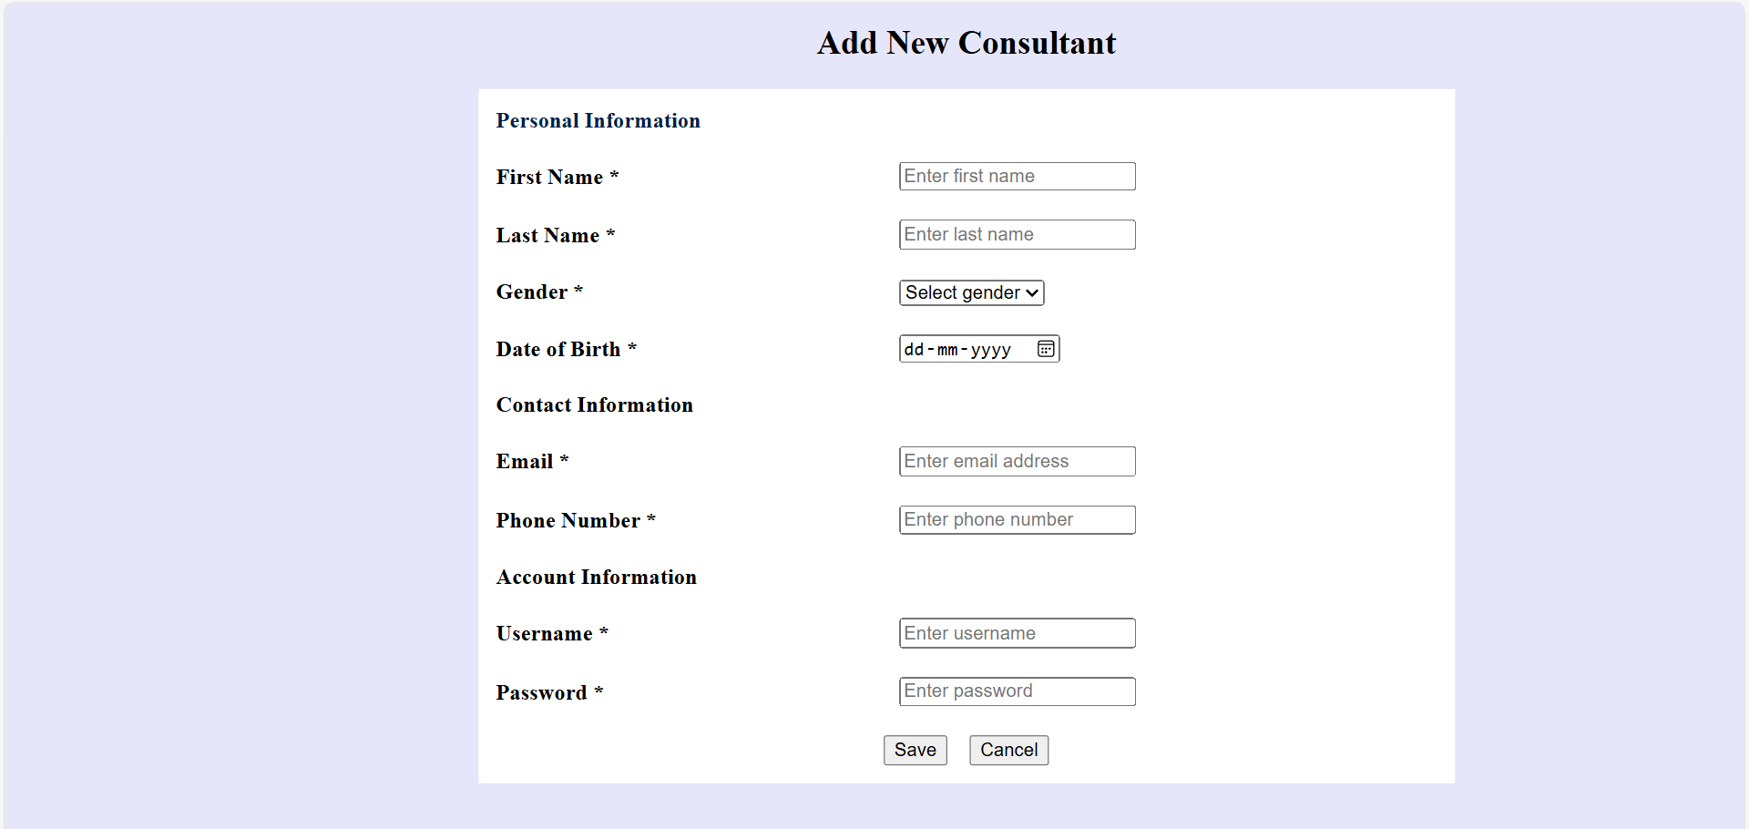

Validation Rules:

🔹 First Name
- Required
- Minimum 4 characters
- Letters only

🔹 Last Name
- Required
- Minimum 4 characters
- Letters only

🔹 Gender
- Required
- Must select value

🔹 Date of Birth
- Required
- Must not allow today or future date

🔹 Email
- Required
- Must be valid format (e.g., abc@test.com)

🔹 Phone Number
- Required
- Must be exactly 10 digits
- Numbers only

🔹 Username
- Required
- Minimum 5 characters
- No spaces allowed

🔹 Password
- Required
- Minimum 6 characters

Functional Requirements:
✔ Show alert messages for invalid inputs
✔ Set focus back to incorrect fields
✔ Do not submit until all validations are passed
✔ On success, show a confirmation message
✔ Cancel button must clear the entire form

